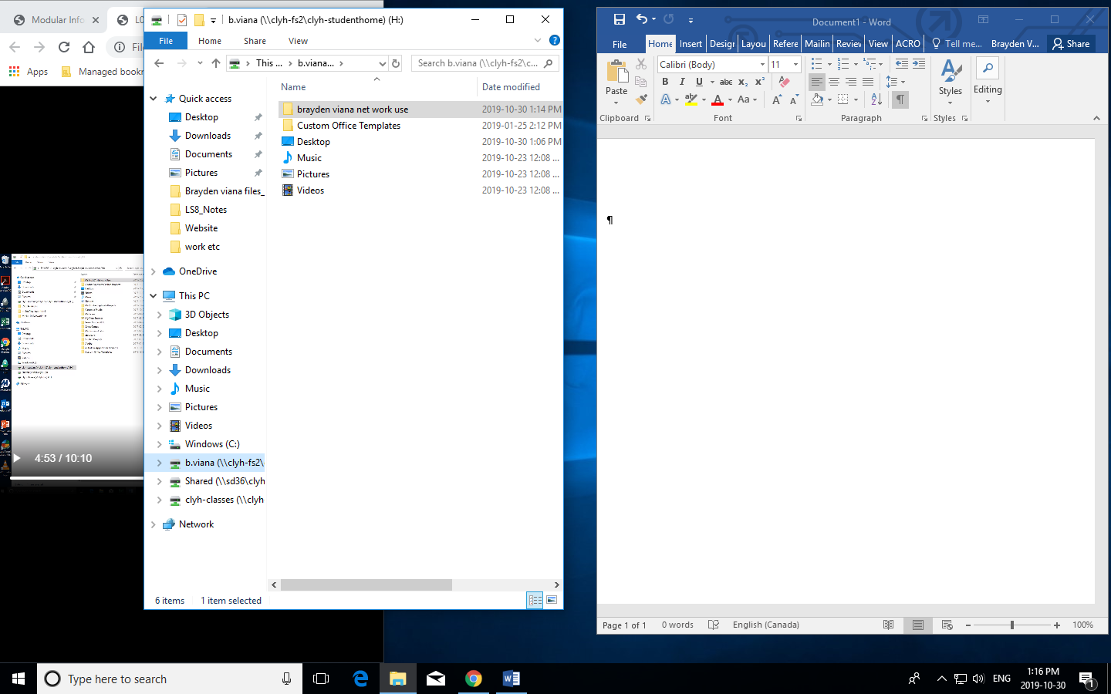

MY H drive

Stuff stuff …